Nicholas Ang

CS457

Project Assignment 2

PA2 Design Document

Records are stored in a row based format where a record has all the attributes of the table.

When records are inserted, they are placed into the text file line by line. Everything that corresponds to a record is on the same line. Users are able to manipulate the records and tuples using the insert, update, delete, and select commands.

Tables are in the format of a line of attributes and then lines of records or tuples. For example, it would look like:

pid int|name varchar(20)|price float

1|Gizmo|14.99

2|PowerGizmo|49.99

To insert values, the user has to type in the INSERT command with its proper parameters. It checks for any commas in the string and replaces it with bars. If there are empty parameters in the inserted record, the parameter is set to NULL. It then checks if the line has actual parameters and adds it to the file. The newly inserted line is appended after the last line in the file.

Updating a record requires users to type in the UPDATE command with proper SET and WHERE values and fields. WHERE has 4 different operators which are =, !=, >, and <. It finds records that satisfy the where values and updates them with the new set values. The program checks the location and column number of the where values to ensure that it is the correct tuple. Then it modifies the string to find what values are set to be replaced. The values are replaced and then the program adds it all into a file.

Deleting a record uses the DELETE command and gets the file name after the FROM and has deletes based on the WHERE clause. WHERE has 4 different operators which are =, !=, >, and <. If it is equal, the program finds where the values are equal and in the correct column to delete them from the file. If it is not equal, the program finds where the values are not equal and deletes them. If it is greater than, it only works with numerical values and checks if the found value is greater than the where value to delete the line. If it is less than, it only works with numerical values and checks if the found value is less than the where value to delete the line. The file essentially skips the deleted line and does not add it into the new file that replaces it.

Selecting a record takes selected parameters and outputs them using the SELECT command. The SELECT command is different than the SELECT * command. Users select the parameters of fields from the database where the WHERE command is used. WHERE has 4 different operators which are =, !=, >, and <. SELECT can select up to the number of fields in the table so if someone selects name and price, it will output the table with only name and price. If it is equal, the program finds where the values are equal and in the correct column to add them to a temporary file to output from. If it is not equal, the program finds where the values are not equal to the WHERE value and adds them to the temporary file to output. If it is greater than, it only works with numerical values and checks if the found value is greater than the where value to output the selected parts of the record. If it is less than, it only works with numerical values and checks if the found value is less than the where value to output the selected parts of the record.

The program is compiled inside the folder with the p2.cpp file using *g++ p2.cpp -o p2* in the terminal.

The program can be used with file arguments using the command *./p2 “File Name”*. It parses all the commands in the file and executes them.

Example Use: *./p2 PA2_test.sql*

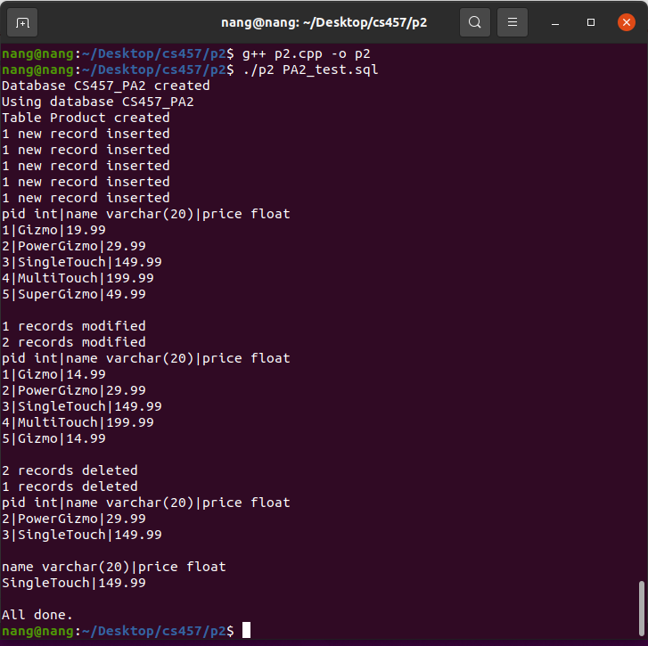

Calling the program without any file arguments *./p2* opens the program in interactive mode. Users can type in the commands to use the database system.

